PEAS Prototype

Overall Architecture

The current design thinking of the PEAS prototype involves not only the core functionality of PEAS but also suggests possible designs for the integration points between PEAS and the rest of TMT software.

In the overall architecture diagram (figure 1) these integration point designs are:
- The Base Observatory Rich Client Platform, which would be a common user interface that the PEAS user interface would plug into.
- The telescope ESB, which in the PEAS design must include a rules engine for commands that allows PEAS (and potentially other subsystems) to command other subsystems when the rules allow it, e.g. when not performing normal observing.

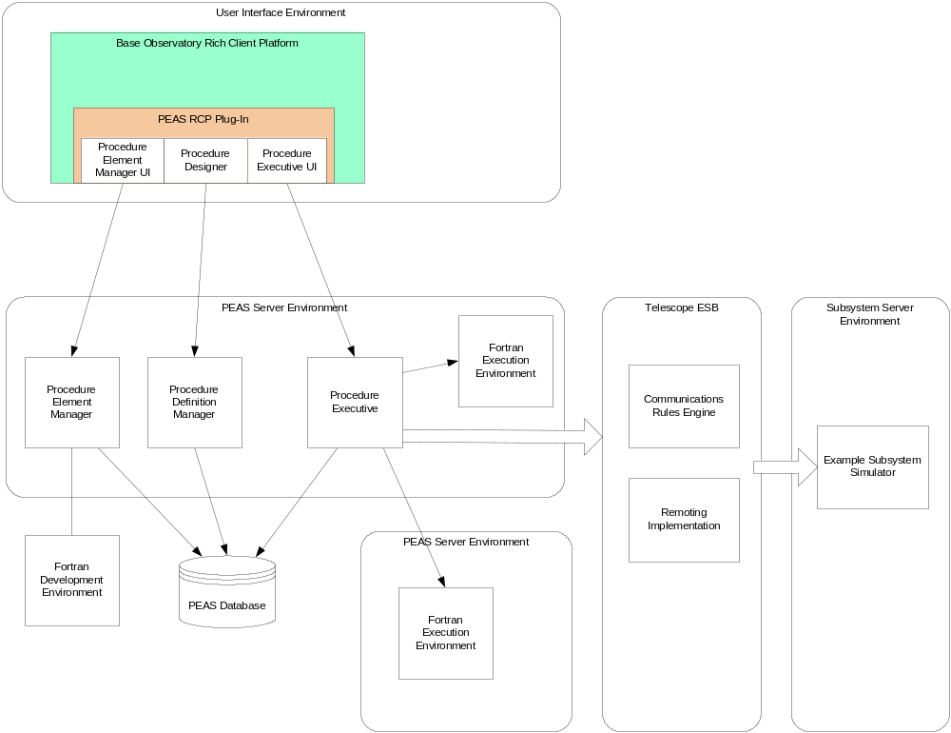

Although these integration point designs are important for discussion and potential demonstration, they are considered lower priority than the core PEAS demo, and will be prototyped only as time allows.

The core PEAS functionality design and implementation will be divided into phases, working from the core workflow outwards (see figure 2).

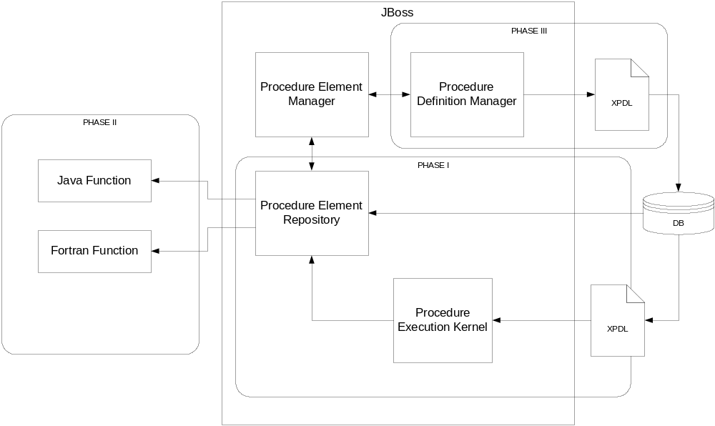

The first phase demonstrates that a workflow kernel designed around XPDL can be implemented easily and that this implementation will be sufficient for PEAS.

The second phase will add remote execution and multi-language support (Fortran).

The third phase will add the procedure definition manager functionality and user interface.

The fourth phase will add the procedure element manager functionality and user interface.

The fifth phase will add a user interface over the kernel execution.

The (optional) sixth phase will prototype a rich client platform that permits the PEAS UI to run as a plug-in.

The (optional) seventh phase will prototype an ESB and rules engine that will control command traffic for TMT software communications.

Procedure Workflow Kernel

Procedure Execution

Workflow Execution Kernel Classes

Process Controller
The process controller is a singleton class and the sole command interface to starting and querying workflows. Given a workflow definition and a set of initialization parameters, the process controller will start a new workflow process.

The process controller is also responsible for maintaining a list of all running processes and can respond to queries on individual process states. The process controller also enables process aborting.

Active Process
When the process controller starts a process, it creates a new active process object initialized with the process definition and initialization parameters.

The active process is responsible for the running of a single workflow instance. There may be more than one active processes running concurrently.

The active process maintains the state of the process through a separate object: the active process state.

The active process is contains the logic to process each workflow step and start each new step once completed. The active process is responsible for handling initialization parameters, managing actual parameter mapping for each step actual input parameter and storing each step actual output parameter.

Active Process State
The active process state maintains and manages state information on a running workflow. The state of each defined activity (not started, running, completed) is maintained.

The active process state supports an API for:
- Returning a list of first activities to be performed for the workflow
- Setting the state of an activity
- Returning a list of activities to be performed next given a completed activity

Step Worker Thread
A thread that runs a remote process step. Supports an API to invoke a method call on the remote object that will actually process the step

Data Classes Supporting the Workflow Execution Kernel
Note: these should be reviewed for possible rework.

Process Step Descriptor
The process step descriptor contains all relevant information about a process step including the activity id, and remote target name, target interface name and target method name.

Activity State
The activity state class maintains the state of an activity: not started, started, completed and exception. This class also maintains the static relationships between an activity, its application task, and its application.

Argument Descriptor
The argument descriptor class contains all relevant information about an application function argument.
It is not clear why this class needs to exist separate from the definition classes.

Argument Value
The argument value is a class that contains an argument descriptor and its value.

Task Application Value
Each task application value describes an input/output value associated with a completed task application (which is associated with an activity).
It is not clear why this class needs to exist separate from the definition classes.

Starting a Workflow Execution
The following diagram (figure xx) shows how the kernel classes collaborate to start a workflow execution.
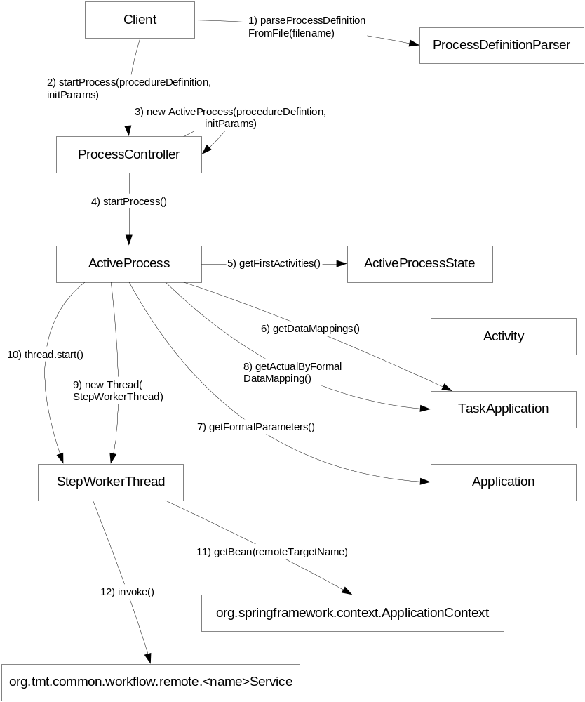

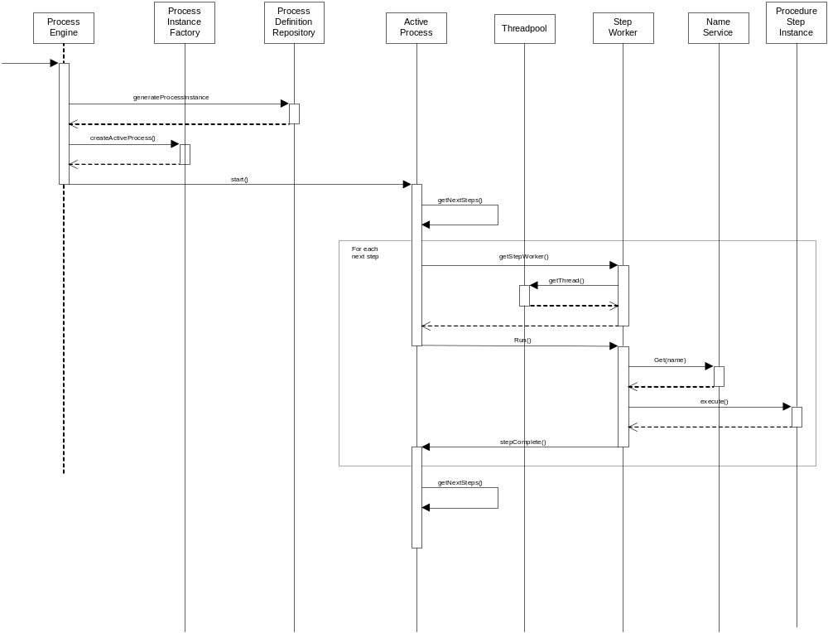

Workflow Definition Classes
The workflow definition model classes (figure ?) correspond closely to XPDL elements. The Procedure Definition class contains the activities, transitions, applications, formal input parameters and data defined in the procedure.

For the purposes of PEAS, all activities are associated with a task application that is associated with an application defined within the procedure. Within XPDL, activities are not restricted to programmatic tasks as will probably be true in all cases for PEAS.

Each activity has one or more transition restrictions (parallel processing joins). Each application has one or more formal parameters that are defined to be passed to the application. Each task application is an instance of calling the application with real parameters, which are derived from the data mapping.

A transition defines a next activity for a given activity. There can be any number of transitions for a given activity. The transition restriction for an activity determines when the transition can be allowed to take place.

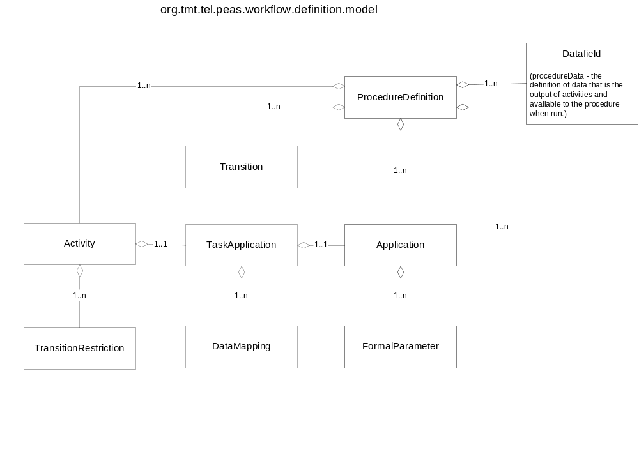

User Interface

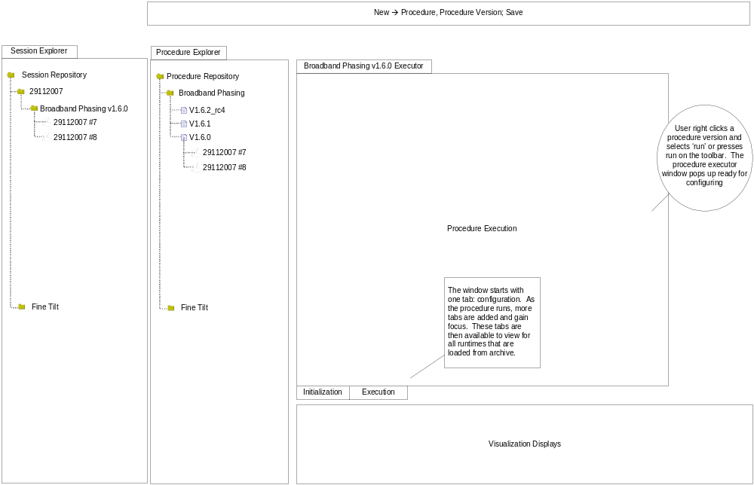

Persistence Strategy
The data corresponding to a procedure execution will need to be stored in the database. The data to be stored is:
- Procedure Definition Id
- Init parameter values
- Runtime step output: activeProcess.processData. This will need to be refined.

Database Schema

TBD

Implementation Notes
<Describe the demo environment: what needs to be installed on a machine for the demo of this phase to work. What are the artifacts produced and where are they stored. What directory structures are used and how are they used.>

Fortran Interoperability

Java to Fortran Interface

Product Survey

Product | Java to C | Java to Fortran | Comments
JNative | yes | no | No activity since 2006
JNA | yes | no | Looks to be well supported in the community
Nlink | yes | no | Seems a little light on documentation, MIT license
j-interop | yes | no | COM/DCOM only product
JNIEasy | yes | no | Uses JNO (java native objects) - need to study this more – competitor to SWIG. Need to check what platforms are currently supported.
JNIWrapper | yes | no | Professional product, not free. Good platform support. At version 3.6. Not sure how automated it is.
xFunction | yes | no | Professional product, not free.
SWIG | yes | no | Interface from c/c++ to many languages. Looks like this was originally created to call c/c++ libraries from scripting languages.
Babel | yes | yes | Babel is the one that does Fortran. It may be complicated, and supports many interfaces/languages that we do not need. Requires the use of an IDL (SIDL).

There does not appear to be any products that can automate the generation of Java interfaces without an intermediate step that requires user interaction: e.g. the usage of an IDL. The goal is to support all this though automated or semi-automated tools. We want to use other product inasmuch as they will benefit this goal.

Some of the projects appear to have become inactive, and support for such products would be non-existent. The risk in using any off-the-shelf product in this area is to have the implementation bound to an unsupported product. If however, the subset of services that we require of these products can be developed in-house using a standards-based approach at an acceptable cost, then that route should be pursued.

Potential Approaches

Approach 1:
- Use xdoclet to parse the Fortran file for tags
- Use something else to generate the c glue code
- Generate the SWIG interface file from the c code and tags
- Use SWIG to generate the JNI code

Approach 2:
- Use xdoclet to parse Fortran for tags that can be converted to SIDL (Scientific Interface Definition Language) tags.
- Use Babel to generate the necessary glue code to Java. Although Babel appears to go end to end, there is a lot to it and we may not require all the baggage.

Approach 3:
- Create the code generation from GFortran to C using tools that we create. Combine this with code generation tools that we create based upon the standard JNI technology to link the C function to a Java method.
- GFortran 4.3 supports C interoperability (ISO Bind C) find out how this can help.

For the demo, approach 3 will be used to determine the risk of developing an in-house solution.

Fortran Source Code Documentation

Source Code Documentation Requirements
Documentation will be necessary for both IDL and internal Fortran source code. I believe that the documentation for a program should reside within the source itself. The IDL documentation is handled from the tool, which might be able to self populate most fields from appropriate tags in the Fortran source code. In fact, we should invent tags in the Fortran source that indicate if the function will be externalized. Then the tool can be given the Fortran file and the IDL could be constructed from the tags.

This means that the Fortran code will potentially require markup for Fortran-only documentation tools (if we decide these are useful) and self-styled markup for the IDL. The markup that the tool will require to generate IDL are:

- external function declaration
- function name
- function short description
- function long description
- function argument and short description/datatype/inout info.
- function argument units
- function argument long description

Survey of Fortran Source Code Documentation Tools

Product | Comments
F90doc | LaTeX output only

Questions
- Do we want to use the Fortran-only documentation tools? Advantage: these will enable following the call-tree in documentation. Disadvantage: this set of documentation may be more difficult to integrate into the rest of our source code documentation. We should make it a design goal to make sure the artifacts are HTML for both.

- What Fortran only tools do we want to use? We need to be careful at this stage since the tool we use will probably end up changing if the project wants that - I don't want us to be in the position we were in at Keck: being out of standard because we were first.

- Determine if BABEL will work for us or if the JNI and IDL generation from Fortran tags can be done using scripts. One point is that BABEL claims to be faster than JNI. This needs to be tested.

- I will need a copy of the Fortran compile and run environment that we will be using in order to run the appropriate tests and to develop the tag library.

- Is there a current decision on the Fortran compiler and runtime environment?

Overall Design
The general design involves a Fortran file marked up with xml to describe the functions and subroutines, a code generator that creates a library file and a java source file from the Fortran file that allows the Fortran functions and subroutines to be called from Java.

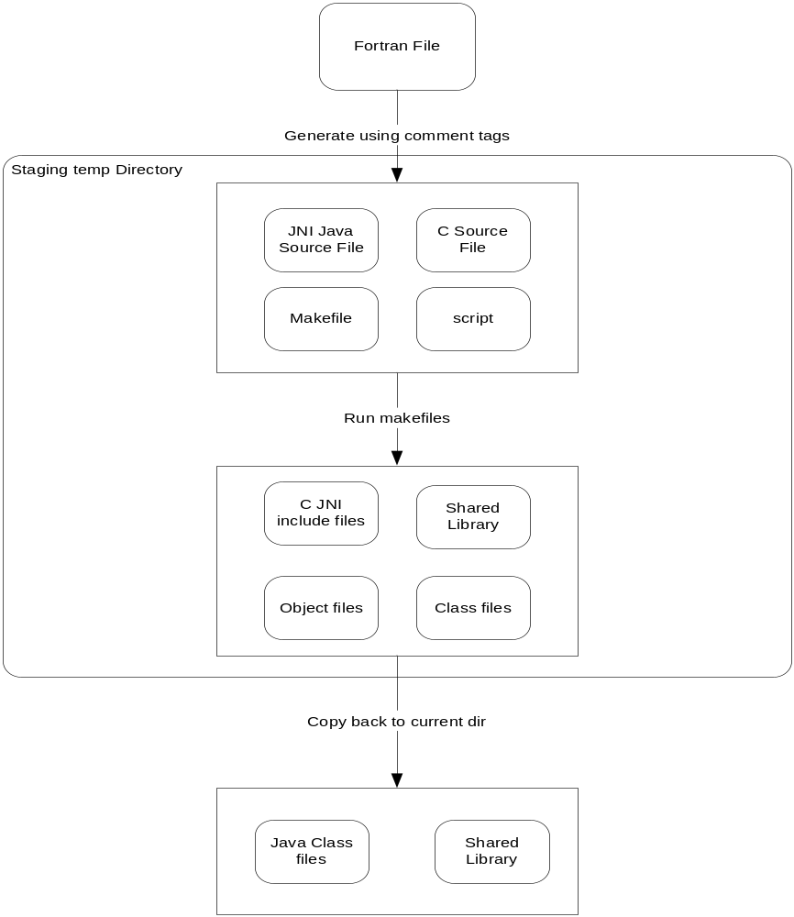

A Java program was produced that would read a set of XML tags within Fortran comments and generates all the necessary artifacts in a temp directory, outputting a library file and java source file. The prototype in the first stage is generalized to handle all scalar argument data types and supporting any number of input and output arguments.

As a second phase, the interoperability was expanded to include support for passing 1-d arrays back and forth. Due to the fact the Fortran, C and Java do not use the same multidimensional memory ordering approaches, appropriate conversions may create a performance problem.

Object Model
<diagram out the object model of the code generator>

Demo Installation and Execution

Within the Linux Ubuntu operating system, GFortran version 4.2 and Java 1.5 were installed.

The Phase V Java program was produced using the Java2Fortran eclipse project. The java2fortran.jar file can be produced using the ant make applied to the project build/build.xml file.

Copy the jar file to the demo installation directory: /home/smichael/TMT/j2f

The code generation code can be applied to an appropriately marked up fortran file in the installation directory:

java -classpath java2fortran.jar org.tmt.aps.peas.j2f.J2FCodeGenerator fsum.f

At this point, a Java program can be created to call the generated Jsum.sum method. The java execution must include the java library path that includes the generated library file:

Java –Djava.library.path=. Main

<Describe the demo environment: what needs to be installed on a machine for the demo of this phase to work. What are the artifacts produced and where are they stored. What directory structures are used and how are they used.>

Remoting Architecture

Overall Design
The design involves loading the service libraries and java files into an application server (JBoss) and creating a remote interface so that the java methods can be called remotely.

The remote application server is assumed to be used to provide computation services.

The technology chosen for remoting is Spring HttpInvoker. Substitute protocols can be configured in the Spring Framework to replace the HttpInvoker if performance becomes an issue.

Each service interface is declared in a separate interface and each service implementation is declared in an implementation class. The classes are named: <function>Service and <function>ServiceImpl respectively, where <function> is the name of the remote function to be called. The name for the terminal <function> class when the computation is 100% Java is TBD.

When the destination function is Fortran, the <function>ServiceImpl class will call the J<function> class’s <function> method, the J<function> class being the name of the generated Java class created by running the Java2Fortran code generator detailed in the Fortran Interoperability section.

Spring uses configuration files and system properties to configure the remoting framework and to declare the remote services. Configuration files are used on both the client and server sides:

Process-step-client.xml (name of client configuration file used in demo) :

<beans xmlns="http://www.springframework.org/schema/beans"
xmlns:xsi="http://www.w3.org/2001/XMLSchema-instance"
xmlns:aop="http://www.springframework.org/schema/aop"
xmlns:tx="http://www.springframework.org/schema/tx"
xsi:schemaLocation="
http://www.springframework.org/schema/beans http://www.springframework.org/schema/beans/spring-beans.xsd
http://www.springframework.org/schema/tx http://www.springframework.org/schema/tx/spring-tx.xsd
http://www.springframework.org/schema/aop http://www.springframework.org/schema/aop/spring-aop.xsd">

<bean id="sumServiceHttpInvokerProxy" class="org.springframework.remoting.httpinvoker.HttpInvokerProxyFactoryBean">
<property name="serviceUrl" value="http://192.168.116.128:8080/peas-demo/process-step/SumService-httpinvoker"/>
<property name="serviceInterface" value="org.tmt.common.workflow.remote.SumService"/>
</bean>

<bean id="productServiceHttpInvokerProxy" class="org.springframework.remoting.httpinvoker.HttpInvokerProxyFactoryBean">
<property name="serviceUrl" value="http://192.168.116.128:8080/peas-demo/process-step/ProductService-httpinvoker"/>
<property name="serviceInterface" value="org.tmt.common.workflow.remote.ProductService"/>
</bean>

</beans>

The <beans> tag is general configuration for the spring framework. Each bean defined (sumService and productService HttpInvokerProxies) declare a proxy locally for a remote service. The interface class is specified in the “serviceInterface” property, and the URL of the service is declared in the “serviceUrl” property, which must match the servlet deployment location of the service on the target server machine.

process-step-servlet.xml (name of server configuration file used in demo) :

<beans xmlns="http://www.springframework.org/schema/beans"
xmlns:xsi="http://www.w3.org/2001/XMLSchema-instance"
xmlns:aop="http://www.springframework.org/schema/aop"
xmlns:tx="http://www.springframework.org/schema/tx"
xsi:schemaLocation="
http://www.springframework.org/schema/beans http://www.springframework.org/schema/beans/spring-beans.xsd
http://www.springframework.org/schema/tx http://www.springframework.org/schema/tx/spring-tx.xsd
http://www.springframework.org/schema/aop http://www.springframework.org/schema/aop/spring-aop.xsd">

<bean id="sumService" class="org.tmt.common.workflow.remote.SumServiceImpl" >
</bean>

<bean name="/SumService-httpinvoker" class="org.springframework.remoting.httpinvoker.HttpInvokerServiceExporter">
<property name="service" ref="sumService"/>
<property name="serviceInterface" value="org.tmt.common.workflow.remote.SumService"/>
</bean>

<bean id="productService" class="org.tmt.common.workflow.remote.ProductServiceImpl" >
</bean>

<bean name="/ProductService-httpinvoker" class="org.springframework.remoting.httpinvoker.HttpInvokerServiceExporter">
<property name="service" ref="productService"/>
<property name="serviceInterface" value="org.tmt.common.workflow.remote.ProductService"/>
</bean>

</beans>

In the server case, 4 beans are declared: two for each service, one declaring the service and specifying the implementation class, and the other specifying the httpinvoker which references as properties the service interface class and the service (implementation) bean declared first.

The web.xml specifies the deployed services on the server:

<context-param>
<param-name>contextConfigLocation</param-name>
<param-value>/WEB-INF/process-step-servlet.xml</param-value>
</context-param>

<servlet>
<servlet-name>process-step</servlet-name>
<servlet-class>org.springframework.web.servlet.DispatcherServlet</servlet-class>
<load-on-startup/>
</servlet>
<servlet-mapping>
<servlet-name>process-step</servlet-name>
<url-pattern>/process-step/*</url-pattern>
</servlet-mapping>

The servlet ‘process-step’ is declared to load on startup. The servlet-mapping specifies what matching URL patterns will be processed by the servlet. The contextConfigLocation parameter is set to load the process-step-servlet.xml. Each of these ‘beans’ will be locatable under peas-demo/process-step/<bean-name as specified in the process-step-servlet.xml file>, where peas-demo is the name of the web application, and process-step is the servlet name.

Integration of Fortran Interoperability

The next step is to call a Fortran program remotely from the workflow kernel. The means to accomplish this is to copy a generated library file and the associated generated Java source file from the Ubuntu environment to the eclipse environment. In the future system, this step would be part of the automation of Fortran Interoperability and remoting.

On the target (Ubuntu) machine, a directory was selected as the load library path: /opt/apps/lib. The environment variable LD_LIBRARY_PATH was set to this value, and the corresponding JBoss java.library.path picks up this path automatically.

The native library file: libsum.so was copied to the /opt/apps/lib directory.

The generated Java source file was copied to eclipse for compilation and insertion into the war file. For the purposes of the demo, all language interoperability Java classes are in one package: org.tmt.aps.peas.lang.interop. The remoting impl source file was changed to call the generated Java file’s public method.

A further step is to develop this static remote configuration into a dynamic remoting framework capable of dynamically generating the server war file and client artifacts.

Object Model

Implementation Notes
<Describe the demo environment: what needs to be installed on a machine for the demo of this phase to work. What are the artifacts produced and where are they stored. What directory structures are used and how are they used.>

Procedure Repository

User Interface

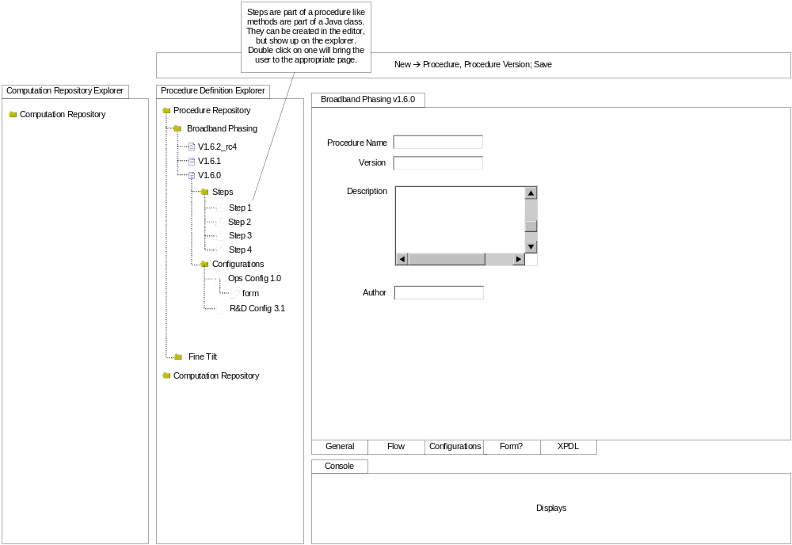

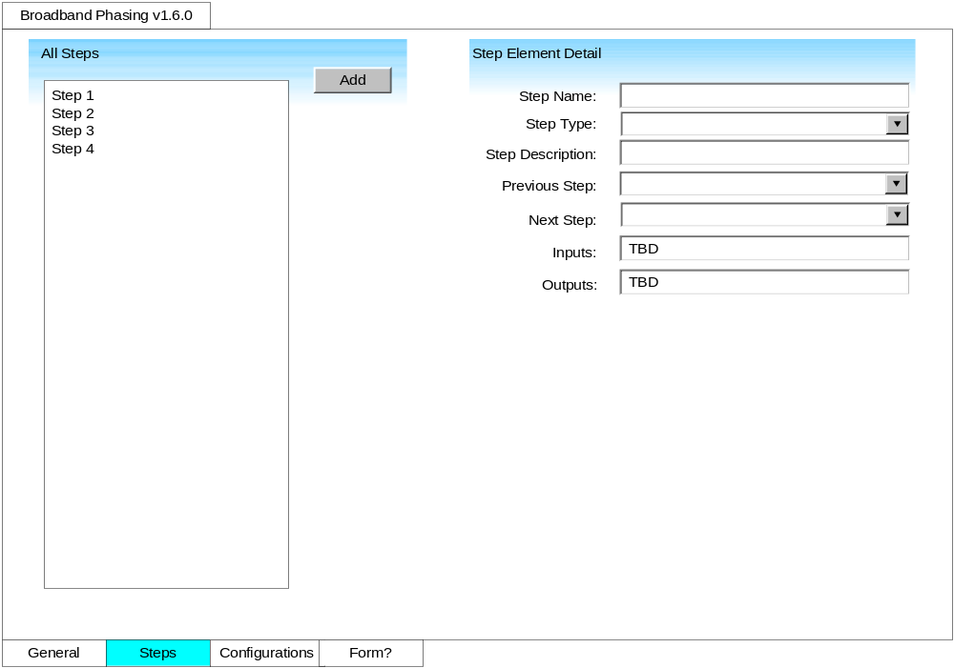

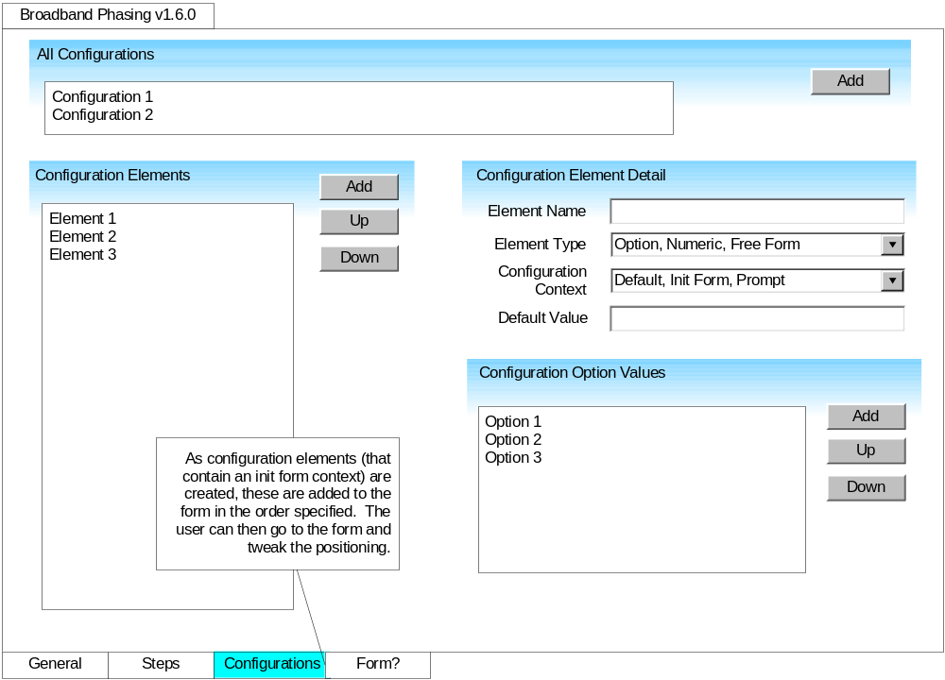

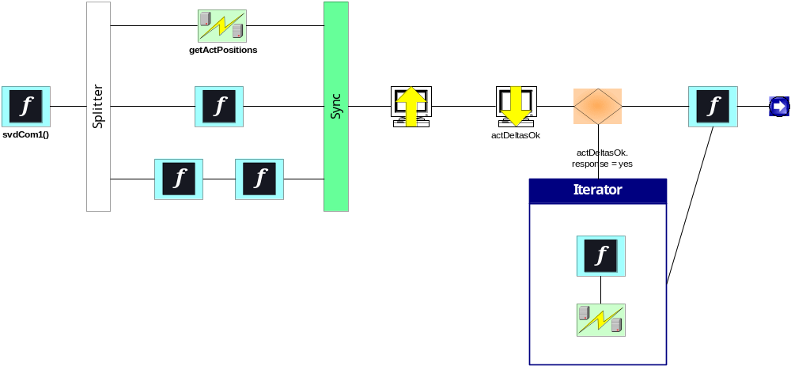

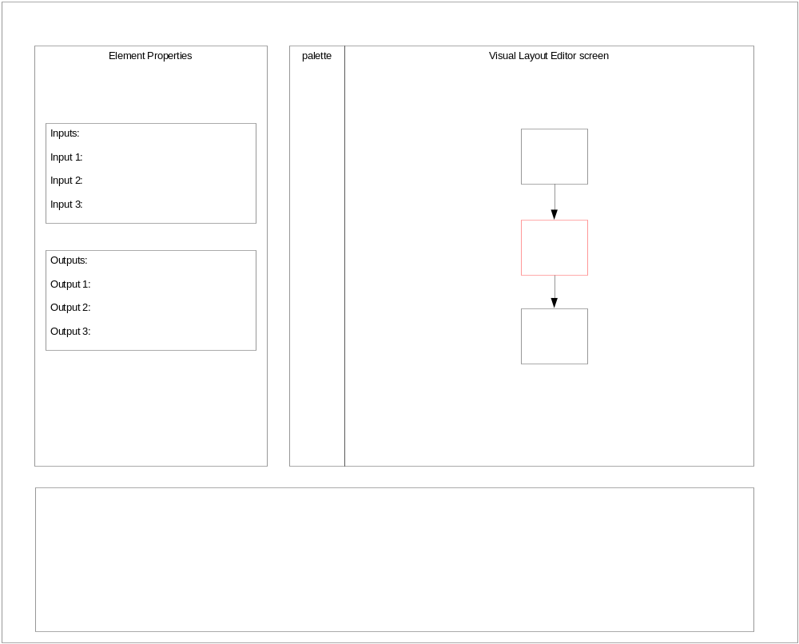

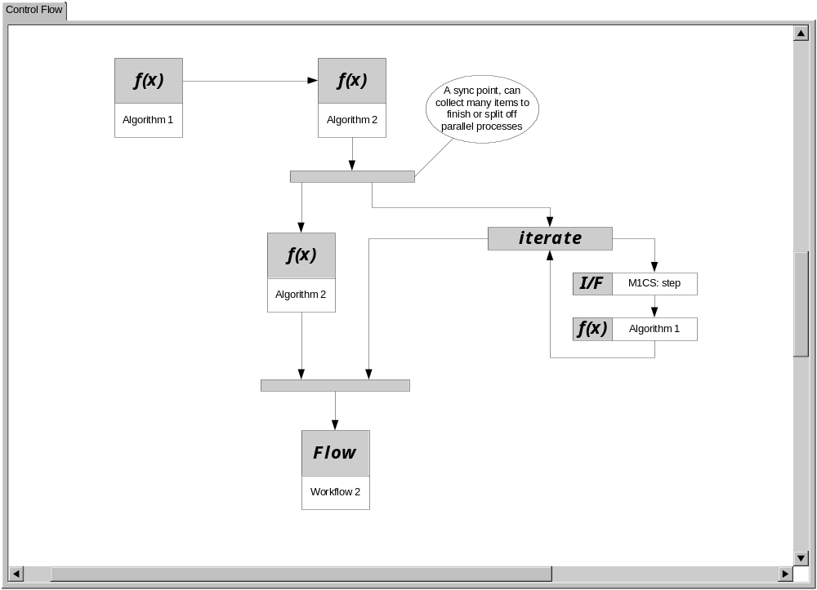

Procedure Element Repository

High Level Design

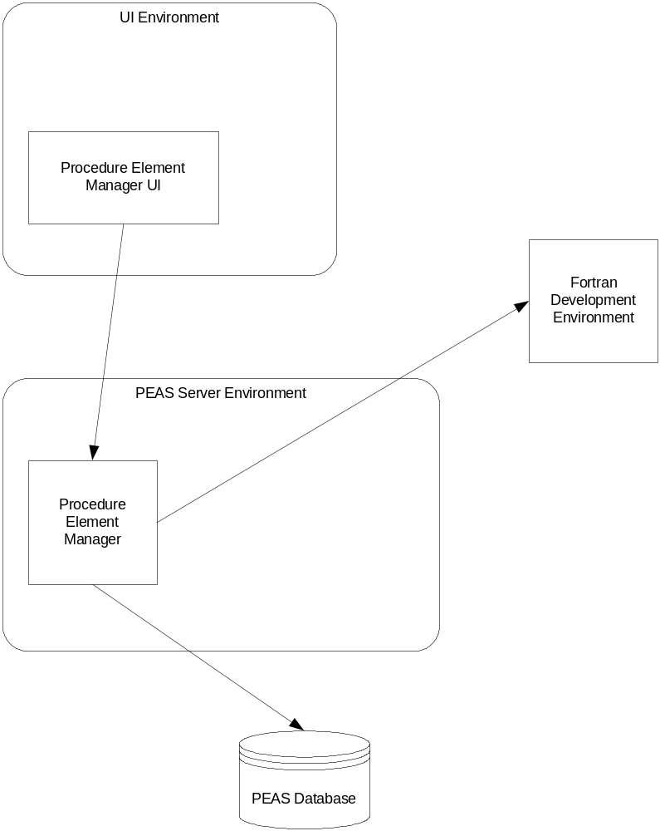

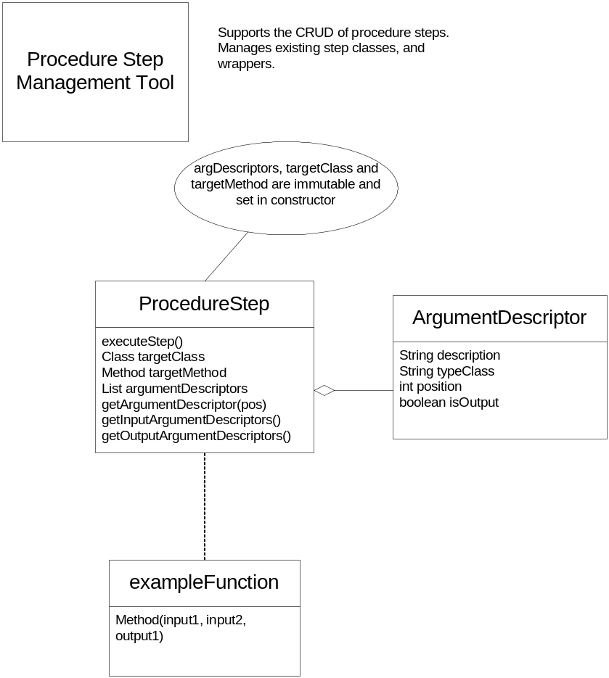

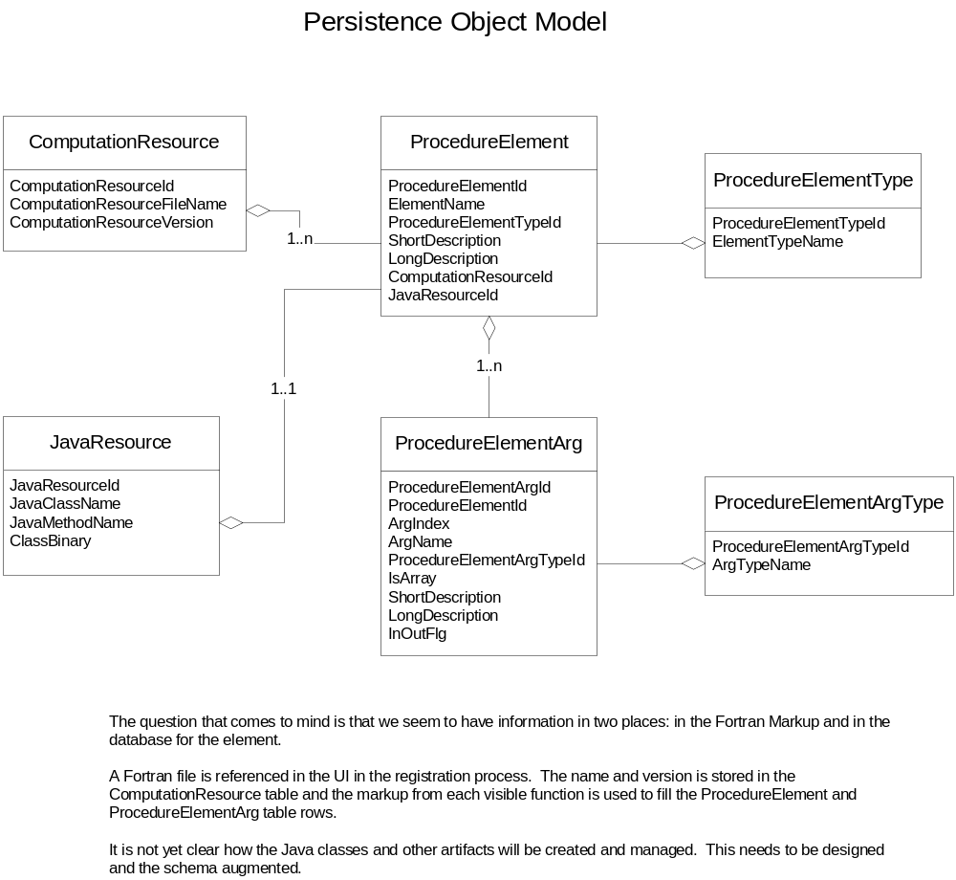

Computation Management

User Interface

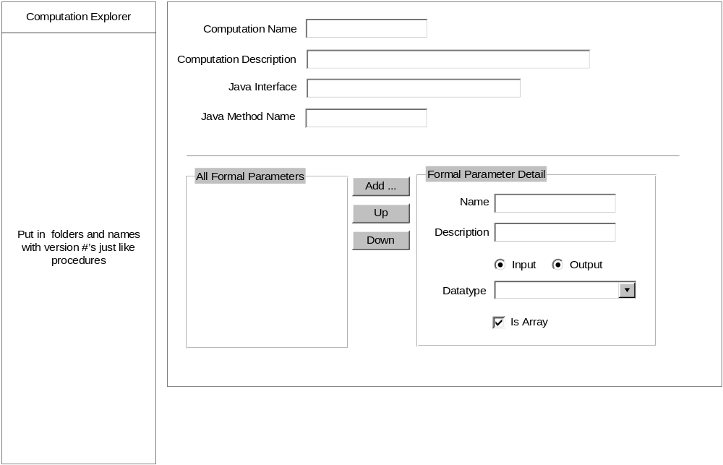

Example Procedures

